# **Algebra & Calculus**

* **Recap (NumPy) - 5'**
* **Algebra - 1hr 10'**
  + Functions
  + Equations
  + Vectors
  + Matrices
  + Matrix multiplication for data science
* **Calculus - 15'**
  + Derivatives
  + Partial derivatives
  + Integrals

🧑‍🏫 [lecture starter for teachers](https://github.com/lewagon/data-lecture-starters/blob/main/starters/03-Math_01-Algebra-Calculus_starter.ipynb)

## **Recap (NumPy)**

### **NumPy is all about handling n-dimensional arrays**

👉 objects of class numpy.ndarray

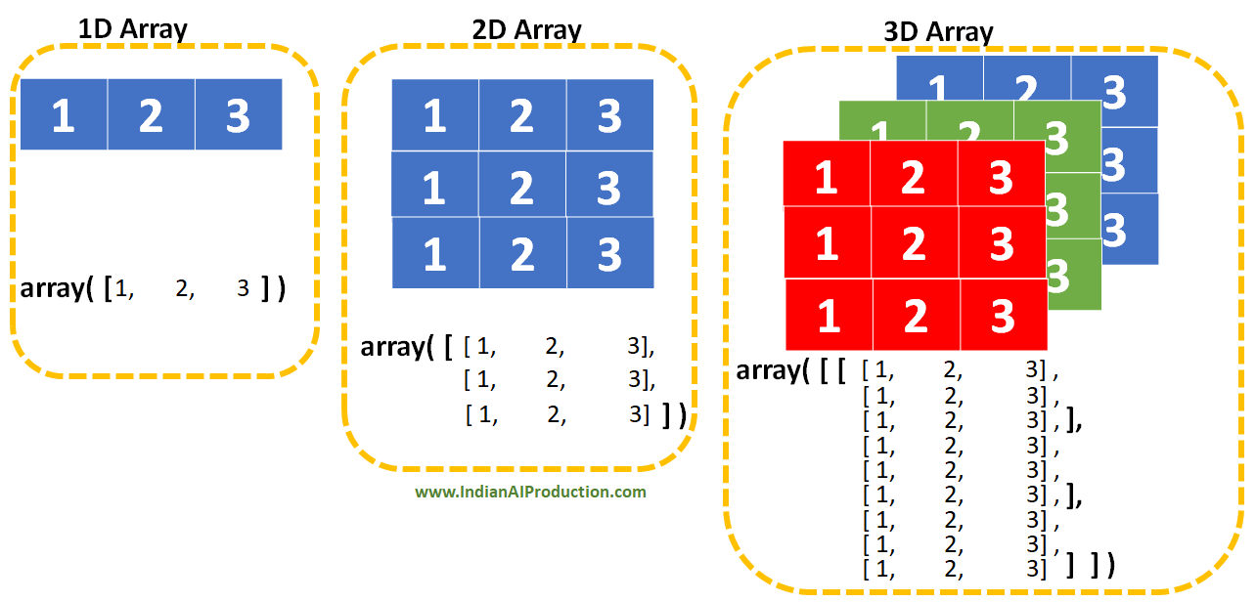

### **NumPy know-hows**

📝 Let's open a notebook

👉 **creating** an array: np.array

👉 important *attributes* of an array: shape, size, ndim and dtype

👉 **extracting** values from an array: *indexing*, *slicing* and *boolean indexing*

**import** **numpy** **as** **np**

A = np.array([[1, 2],

[3, 4],

[5, 6],])

type(A)

numpy.ndarray

A.shape *# very important for today's lecture!*

(3, 2)

print(f"**{**A.size **= }\n{**A.ndim **= }\n{**A.dtype **= }**")

A.size = 6

A.ndim = 2

A.dtype = dtype('int64')

A[1, 1] *# indexing*

4

A[:2, :] *# slicing*

array([[1, 2],

[3, 4]])

A > 2 *# this is a boolean mask*

array([[False, False],

[ True, True],

[ True, True]])

A[A > 2] *# boolean indexing = use a boolean mask as an index*

array([3, 4, 5, 6])

### **NumPy is good for your health 💪**

* [faster computing](https://stackoverflow.com/questions/8385602/why-are-numpy-arrays-so-fast)
* very compact way to code
* same logic applies to Pandas
* 👉 before using a for loop, ask yourself 🤔 ***can i do it the NumPy way?***

# **1) Algebra**

[**Algebra**](https://en.wikipedia.org/wiki/Algebra) is the branch of mathematics that:

* **represents** mathematical objects as symbols
* **manipulates** them in formulas

☝️ Data scientists ❤️ [**Linear Algebra**](https://en.wikipedia.org/wiki/Linear_algebra)

### **Mathematical vocabulary**

Let's have a look at this formula:

x

+

1

=

c

+

y

0

2

+

1

4

y

1

* (
* x
* +
* 1
* )
* and
* (
* c
* +
* y
* 0
* 2
* +
* 1
* 4
* y
* 1
* )
* are expressions
* x
* is a symbol standing for a variable and
* c
* is a constant
* in
* (
* x
* +
* 1
* )
* 👉
* +
* is an operator,
* x
* and
* 1
* are operands
* in
* y
* 2
* 0
* 👉
* 0
* is an index (subscript) and
* 2
* is an exponent (superscript)

🔥 LaTeX syntax in Markdown cell of a Jupyter notebook 🔥

$$ x + 1 = c + y_0^2 + \frac{1}{4} y_1 $$

## **1.1) Functions**

### **Function definition**

👉 A function is a *mapping* of each element from one set to a unique element of a second set.

f

:

R

→

R

,

f

(

x

)

=

x

2

+

1

📝 Let's implement this mathematical function in Python

*# classical way...*

**def** square_plus_one(x):

**return** x**2 + 1

type(square_plus_one)

function

*# ... or using the "lambda" keyword*

square_plus_one = **lambda** x: x**2 + 1

type(square_plus_one)

function

📝 Let's use the square_plus_one function

**for** x **in** range(5):

y = square_plus_one(x)

print(f"**{**x**=}** -> **{**y**=}**")

x=0 -> y=1

x=1 -> y=2

x=2 -> y=5

x=3 -> y=10

x=4 -> y=17

Wait. 🤔 did we just use a for loop?

🤬 ***Let's do it the NumPy way 💪***

x = np.arange(5) *# x contains 5 values*

y = square_plus_one(x) *# y contains 5 values*

print(f"**{**x **= }**")

print(f"**{**y **= }**")

x = array([0, 1, 2, 3, 4])

y = array([ 1, 2, 5, 10, 17])

### **Function representation**

📝 Draw the

y

=

f

(

x

)

curve in an ***orthonormal coordinate system***.

x = np.linspace(-1, 2, 100) *# x contains 100 values*

y = square_plus_one(x) *# y contains 100 values*

plt.plot(x, y); *# plot a line with 100 points*



👉 No **vertical line** can intersect the curve twice 🧐 This is **always** true: one input

x

is mapped to only one output

y

💡 Notice that a **horizontal line** may cross the curve several times 🧐 Several input

x

's may have the same output

y

### **The identity function**



### **Linear functions**

A straight line is defined by the equation

f

(

x

)

=

m

x

+

b

👉

m

is the **slope** and 👉

b

is the **intercept**



❓ can you calculate the **intercept** and the **slope** of any straight line?  
👉

b

=

f

(

0

)

and 👉

m

=

f

(

x

B

)

−

f

(

x

A

)

x

B

−

x

A

### **Non-linear functions**

👉 square_plus_one is not linear. Here are some more examples ⤵️



### **Inverse function (**

### f

### −

### 1

### **) of a function**

### f

👉 An inverse function

f

−

1

is a function that "reverses"

f

f

−

1

(

f

(

x

)

)

=

x

and

f

(

f

−

1

(

x

)

)

=

x



💡 The representation of

f

−

1

is the mirror image of

f

through

y

=

x

⚠️ Not all functions have an inverse.

f

has an inverse iff (if and only if)

f

is a [bijection](https://en.wikipedia.org/wiki/Bijection).  
💡 Graphically, it means **no** *horizontal line* can intersect the curve more than once.



### **Multi-variate functions**

👉 A multi-variate function takes 2 input variables or more.

f

:

R

2

→

R

,

f

(

x

1

,

x

2

)

=

2

x

1

−

3

x

2

+

7

**import** **plotly.graph_objects** **as** **go**

fun = **lambda** x, y: 2*x - 3*y + 7 *# bivariate function*

x, y = np.meshgrid(range(10), range(10)) *# grid of x's and y's*

z = fun(x, y) *# z's*

fig = go.Figure(go.Surface(x=x, y=y, z=z)); fig.show()



## **1.2) Equations**

👉 An equation is a formula that contains one or more unknown variables

2

x

=

4

👉 A system of equations is a collection of two or more equations involving the same set of unknowns.

⎧

⎪

⎨

⎪

⎩

3

x

+

2

y

−

z

=

1

2

x

−

2

y

+

4

z

=

−

2

−

x

+

1

2

y

−

z

=

0

👉 A solution is a set of values of the unknown(s) that satisfy all these constraints.

⚠️ Depending on the equation, there may be:

* 2
* x
* =
* 4
* 👉 **one** solution
* x
* 2
* =
* 4
* 👉 **two** solutions
* ...
* x
* =
* x
* 👉 an ***infinity*** of solutions
* x
* =
* x
* +
* 2
* 👉 **zero** solutions

🤔 Problem:

* A father is 22 years older than his daughter.
* In 10 years, the father will be twice as old as his daughter.

**How old are they?**

👉 This translates into a system of two equations with two unknowns. Let

y

be the father's age and

x

his daughter's age.

{

y

=

x

+

22

(

1

)

y

+

10

=

2

(

x

+

10

)

(

2

)

...which simplifies to:

{

y

=

x

+

22

(

1

)

y

=

2

x

+

10

(

2

)

👉 We can solve this graphically 📈

💡 The blue line is the set of

(

x

,

y

)

that satisfy equation

(

1

)

💡 The orange line is the set of

(

x

,

y

)

that satisfy equation

(

2

)



👀 It seems there is one and only one point

(

x

,

y

)

that satisfies both equations

(

1

)

and

(

2

)

.

The *high school* method 🧑‍🏫 can get us to the exact answer:

👉 combine

(

1

)

and

(

2

)

:

x

+

22

=

2

x

+

10

, from which

x

=

12

👉 finally

(

1

)

:

y

=

12

+

22

=

34

🥱

💡 today we will also solve this problem using linear algebra 🎉

## **1.3) Vectors**

### **1.3.1) What's a vector?**

👉 In a **plane**, a geometrical vector is defined by 2 points or by a magnitude, a directionand a sense.

💡 Note that

→

A

B

=

→

A

H

+

→

H

B

and

→

A

B

=

→

C

D



### **Coordinates**

👉 If we have an origin

O

and two unit vectors

→

ı

and

→

ȷ

, any **vector** is uniquely defined by two coordinates.



💡 Conversely, any **couple** of numbers can be understood as a **point** in a plane, and as a **vector**.

### **Notation**

👉 A vector:

* with an arrow on top 👉
* →
* a
* or as a **bold**, *italic, lowercase* symbol 👉
* a

a

=

[

1

2

]

or

[

1

2

]

The unit vectors are

i

=

[

1

0

]

and

j

=

[

0

1

]

👉 By contrast, a scalar (= a simple quantity, a number): **not bold**, *italic, lowercase* symbol 👉

a

### **Vectors in higher dimensions**

👉 Vector

a

=

[

1

2

]

*lives* in a **2D space** (= a plane)

👉 Vector

u

=

[

1

2

3

]

*lives* in a **3D space**

👉 Vector

x

=

[

x

1

x

2

.

.

.

x

n

]

*lives* in a... **n-dimensional space**! 🤩

💡 At the end of the day, you can think of a vector **both** as:

* a **sequence of**
* n
* **numbers**
* a **point** in a **n-dimensional space** 🎉

### **1.3.2) Vectors are everywhere in data science!**

👉 Imagine a dataframe of data on apartments. For each apartment (row), 3️⃣ numerical features (columns) are available.

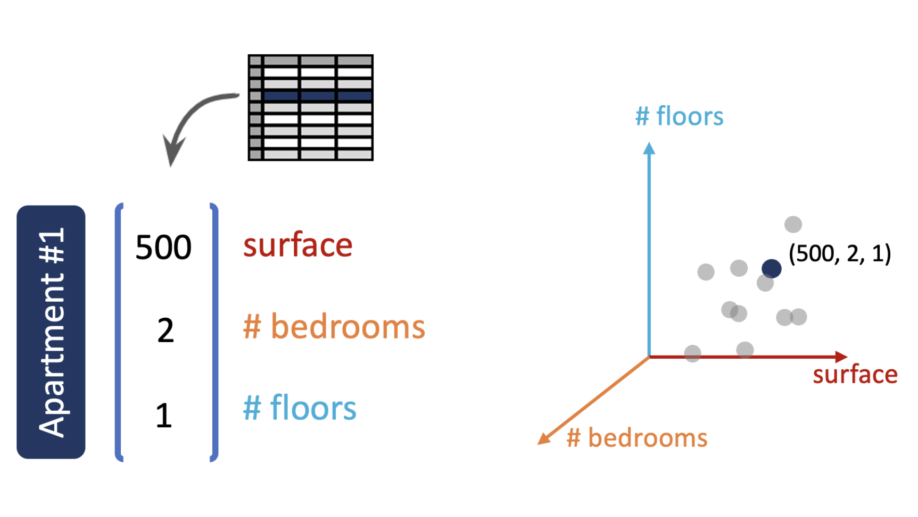

👉 Each apartment is represented by a vector of size 3, or a point in a 3D space. 😮 So the whole dataset can be viewed as a point cloud in that 3D space.

🤔 Now what if there are *more* than 3 features?

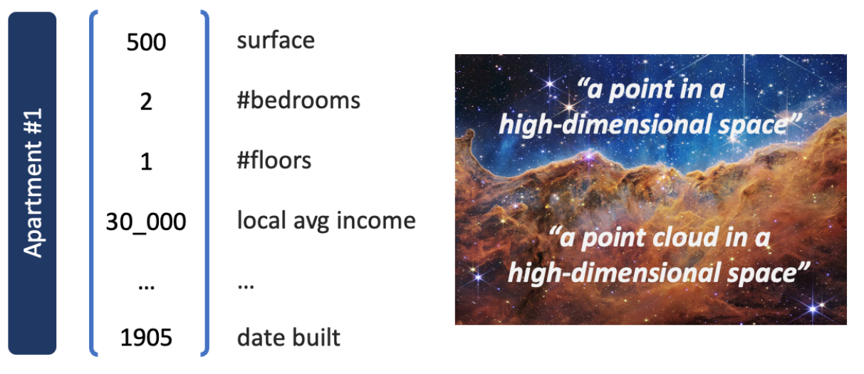

### **1.3.3) Vectors and basic operations with NumPy**

u = np.array([1, 2, 3]) *# shape (3,)*

u_row = np.array([[1, 2, 4]]) *# shape (1, 3) (row vector)*

u_column = np.array([[1], [2], [3]]) *# shape (3, 1) (column vector)*

#### **👉 Add two vectors**

v = np.array([4, 5, 6])

u + v

array([5, 7, 9])

#### **👉 Multiply a vector by a scalar (⚠️ ≠ scalar product ⚠️)**

2 * u

array([2, 4, 6])

### **1.3.4) Distance between two vectors - Norm of a vector**

👉 The L2 **distance** between vectors

a

and

b

is the euclidean distance 📏,

A

B

from point

A

(

a

x

,

a

y

)

to point

B

(

b

x

,

b

y

)

.

👉 The L2 **norm** of vector

a

, denoted

|

|

a

|

|

2

, is the distance from

O

(

0

,

0

)

to

A

(

a

x

,

a

y

)

.

💡 Since

→

A

B

=

→

O

B

−

→

O

A

, the L2 **distance** between

a

and

b

is actually the L2 **norm** of vector

b

−

a

:

A

B

=

|

|

b

−

a

|

|

2



According to Pythagoras' theorem:

A

B

=

√

(

b

x

−

a

x

)

2

+

(

b

y

−

a

y

)

2

O

A

=

|

|

a

|

|

2

=

√

a

x

2

+

a

y

2

🤔 Can we measure 📏 distances in a **n-dimensional** space?

O

A

=

|

|

a

|

|

2

=

√

a

1

2

+

a

2

2

+

.

.

.

+

a

n

2

=

⎷

n

∑

i

=

1

a

2

i

A

B

=

|

|

b

−

a

|

|

2

=

√

(

b

1

−

a

1

)

2

+

(

b

2

−

a

2

)

2

+

.

.

.

+

(

b

n

−

a

n

)

2

=

⎷

n

∑

i

=

1

(

b

i

−

a

i

)

2

💡 You'll also encounter the L1 (aka Manhattan or cityblock) **distance**:

|

|

b

−

a

|

|

1

=

|

b

1

−

a

1

|

+

|

b

2

−

a

2

|

+

.

.

.

+

|

b

n

−

a

n

|

=

n

∑

i

=

1

|

b

i

−

a

i

|

📝 Let's compute the L2 distance between

a

=

[

1

2

3

4

]

and

b

=

[

5

5

5

5

]

a = np.array([1, 2, 3, 4])

b = np.array([5, 5, 5, 5]) *# We both live in a 4D space!*

(b-a)

array([4, 3, 2, 1])

(b-a)**2

array([16, 9, 4, 1])

np.sqrt(np.sum((b-a)**2))

5.477225575051661

### **1.3.5) 🔥 Dot product (aka scalar product aka inner product) 🔥**

👉 the **dot product** takes 2 input vectors (of same size) and outputs a scalar (a number)

a

⋅

b

👉 the **dot product** is maximal if the 2 vectors point in the **same direction**:

a

⋅

b

=

|

|

a

|

|

2

×

|

|

b

|

|

2

👉 the **dot product** is null if the 2 vectors are **orthogonal**:

a

⋅

b

=

0

|  |  |
| --- | --- |

[better explained - dot product](https://betterexplained.com/articles/vector-calculus-understanding-the-dot-product/)

Let

a

and

b

two vectors ⚠️ ***of identical size***

n

.

👉 The **dot product** of

a

and

b

is:

a

⋅

b

=

a

1

b

1

+

a

2

b

2

+

.

.

.

+

a

n

b

n

=

n

∑

i

=

1

a

i

b

i

👉 The **dot product** is related to the **angle**

θ

formed by

a

and

b

:

a

⋅

b

=

|

|

a

|

|

×

|

|

b

|

|

×

cos

θ

💡

cos

θ

, aka the cosine similarity, is often used in NLP (Language models)

🧮 Let's compute a dot product by hand!

[

1

2

3

]

⋅

⎡

⎢

⎣

4

5

6

⎤

⎥

⎦

=

?

✅ The *size* of the left vector is equal to the *size* of the right vector ✅

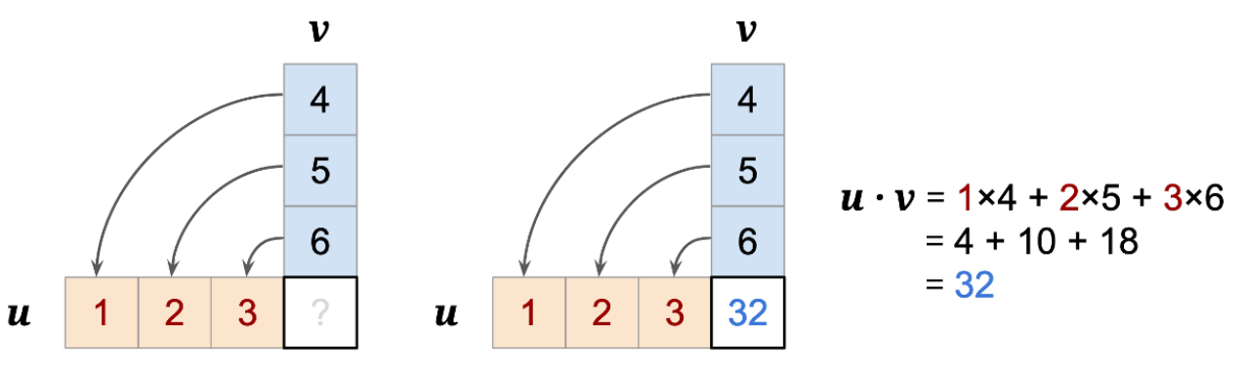

📝 With numpy:

np.dot(u, v) *# or...*

u.dot(v) *# or...*

u @ v

## **1.4) Matrices**

👉 A matrix is a **two-dimensional** array of scalars.

The symbol of a matrix is a **bold**, *italic, uppercase* letter

Example:

A

=

⎡

⎢

⎢

⎢

⎢

⎢

⎢

⎢

⎣

a

1

,

1

a

1

,

2

.

.

.

a

1

,

n

a

2

,

1

a

2

,

2

.

.

.

a

2

,

n

a

3

,

1

a

3

,

2

.

.

.

a

3

,

n

.

.

.

.

.

.

.

.

.

.

.

.

a

m

,

1

a

m

,

2

.

.

.

a

m

,

n

⎤

⎥

⎥

⎥

⎥

⎥

⎥

⎥

⎦

A

is a matrix with

m

rows and

n

columns (shape

m

×

n

)

A matrix can be:

👉 A **collection** of column vectors stacked horizontally

👉 A **collection** row vectors stacked vertically

👉 Any **numerical table** (pandas dataframe...) is a matrix

💡 A **grayscale picture** is also a matrix of numbers representing the black intensity of pixels

### **Basic operations with matrices**

#### **👉 Transpose a matrix**

The transpose of matrix

A

is denoted

A

T



#### **👉 Add two matrices**

Let

A

and

B

two matrices ⚠️ ***of identical shape.***

A

+

B

is a matrix of same shape, computed by element-wise addition.

⎡

⎢

⎣

1

2

3

4

5

6

⎤

⎥

⎦

+

⎡

⎢

⎣

1

4

2

5

3

6

⎤

⎥

⎦

=

⎡

⎢

⎣

2

6

5

9

8

12

⎤

⎥

⎦

#### **👉 Multiply a matrix by a scalar**

The product

λ

A

of a scalar

λ

∈

R

and a matrix

A

is computed by multiplying each element of

A

by

λ

.

3

⋅

⎡

⎢

⎣

1

2

3

4

5

6

⎤

⎥

⎦

=

⎡

⎢

⎣

3

6

9

12

15

18

⎤

⎥

⎦

📝 With numpy:

A.shape *# (n_rows, n_columns)*

A.T *# transpose of A*

A + B *# addition*

3 * A *# scalar multiplication*

### **🔥🔥 Matrix multiplication: Matrix • Vector 🔥🔥**

[

1

2

3

0

1

2

]

⋅

⎡

⎢

⎣

4

5

6

⎤

⎥

⎦

=

?

✅ The number of *columns* of the matrix is equal to the *size* (≈ number of "rows") of the column vector ✅

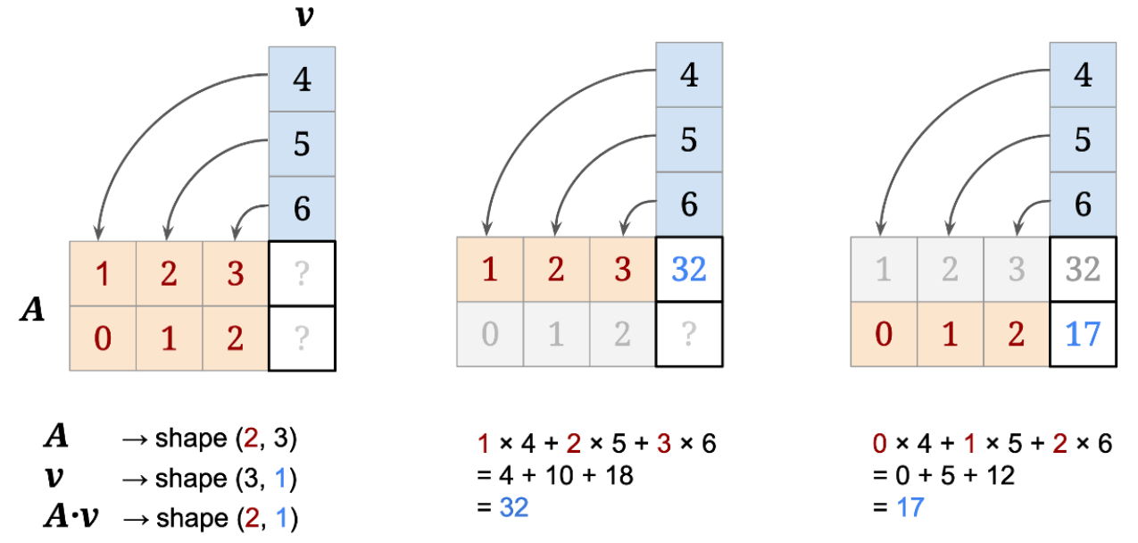

### **🔥🔥🔥 Matrix multiplication: Matrix • Matrix 🔥🔥🔥**

[

1

2

3

0

1

2

]

⋅

⎡

⎢

⎣

4

1

−

1

0

5

0

3

2

6

4

0

1

⎤

⎥

⎦

=

?

✅ The number of *columns* of the left matrix is equal to the number of *rows* of the right matrix ✅

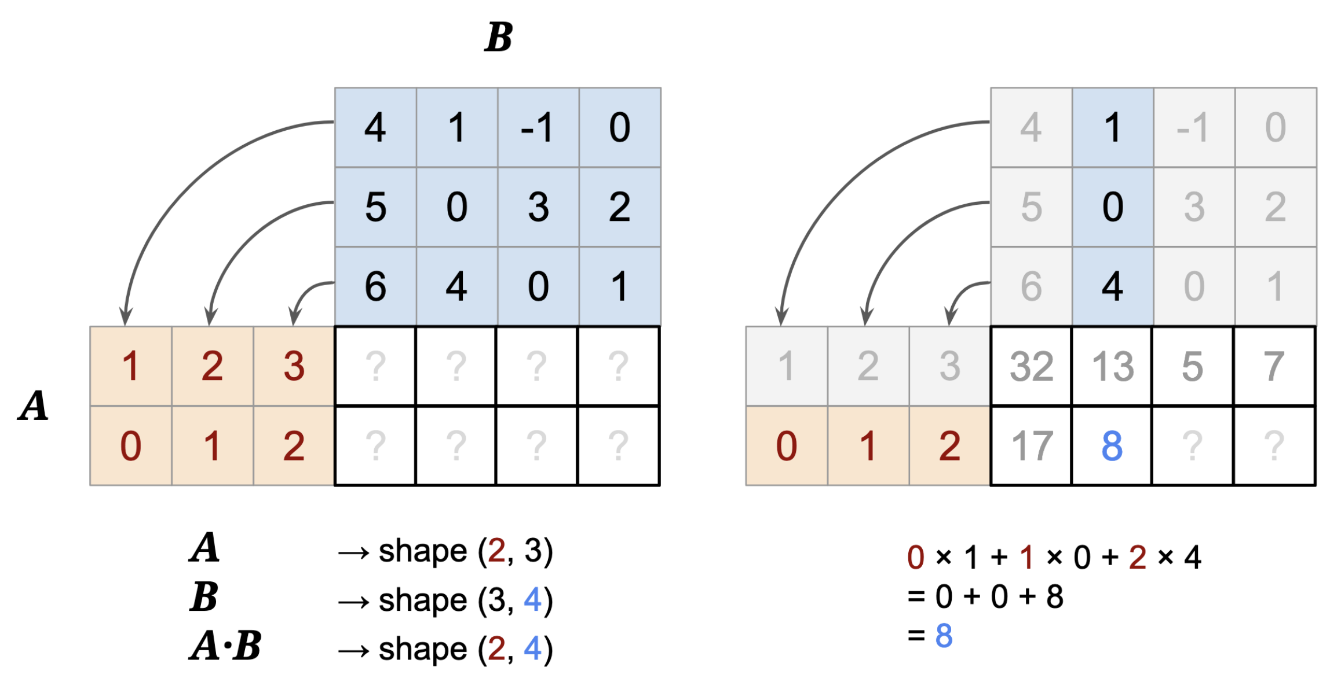

📝 With numpy:

A = np.array([[1, 2, 3],

[0, 1, 2]])

B = np.array([[4, 1, -1, 0],

[5, 0, 3, 2],

[6, 4, 0, 1]])

*# Matrix • Matrix*

np.matmul(A, B) *# or...*

A @ B

array([[32, 13, 5, 7],

[17, 8, 3, 4]])

### **💥💥💥 Shape incompatibility 💥💥💥**

🤔 What if...

❌ the number of columns of the left matrix is **NOT** equal to the number of rows of the right one? ❌

print(f"**{**B.shape **= }** and **{**A.shape **= }**.")

B.shape = (3, 4) and A.shape = (2, 3).

B @ A

---------------------------------------------------------------------------

ValueError Traceback (most recent call last)

Cell In [28], line 1

----> 1 B @ A

ValueError: matmul: Input operand 1 has a mismatch in its core dimension 0, with gufunc signature (n?,k),(k,m?)->(n?,m?) (size 2 is different from 4)

### **More on Matrix multiplication...**

✅ Associative 👉

(

A

B

)

⋅

C

=

A

⋅

(

B

C

)

✅ Distributive 👉

A

⋅

(

B

+

C

)

=

A

B

+

A

C

❌ but **NOT** Commutative 👉

A

B

≠

B

A

### **Identity matrix**

An identity matrix is a square matrix with a diagonal of ones and zeros everywhere else.

I

3

=

⎡

⎢

⎣

1

0

0

0

1

0

0

0

1

⎤

⎥

⎦

Provided the shapes of

A

and

I

are compatible:

A

⋅

I

=

A

and

I

⋅

A

=

A

👉 numpy.eye

### **Inverse matrix**

The inverse of a matrix

A

is a matrix denoted

A

−

1

that satisfies:

A

−

1

⋅

A

=

A

⋅

A

−

1

=

I

⚠️ Only square matrices can have an inverse... and [some square matrices don't have an inverse!](https://en.wikipedia.org/wiki/Invertible_matrix)

👉 numpy.linalg.inv

### **Determinant of a matrix**

A square matrix is invertible *if and only if* its [determinant](https://en.wikipedia.org/wiki/Determinant) is not 0.

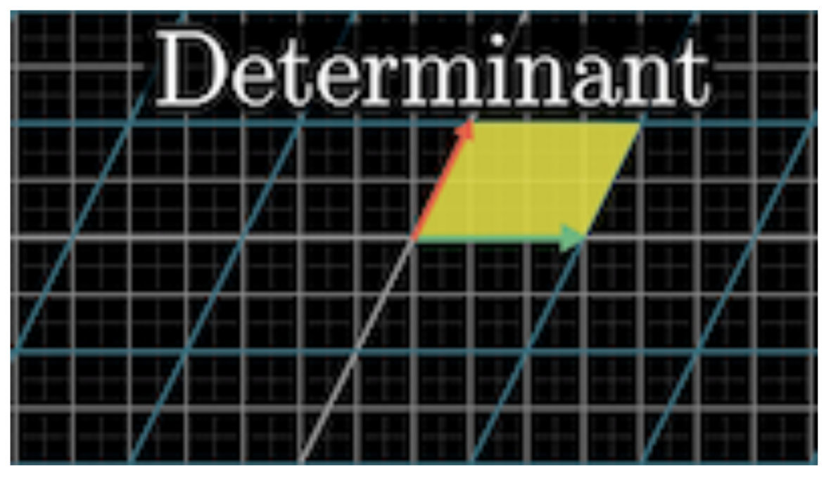

[Linear transformations and matrices](https://www.youtube.com/watch?v=kYB8IZa5AuE&list=PLZHQObOWTQDPD3MizzM2xVFitgF8hE_ab&index=3) by 3blue1brown 🥰

👉 numpy.linalg.det

## **1.5) Matrix multiplication 🤝 data science**

### **1.5.1) Concise code and efficient computation**

y

=

a

1

x

1

+

a

2

x

2

+

.

.

.

+

a

n

x

n

... is equivalent to

y

=

a

⋅

x

👉 Estimate the price of one apartment (

y

) by a linear combination (weights =

a

) of the features (

x

) 🔥 Vector • Vector 🔥

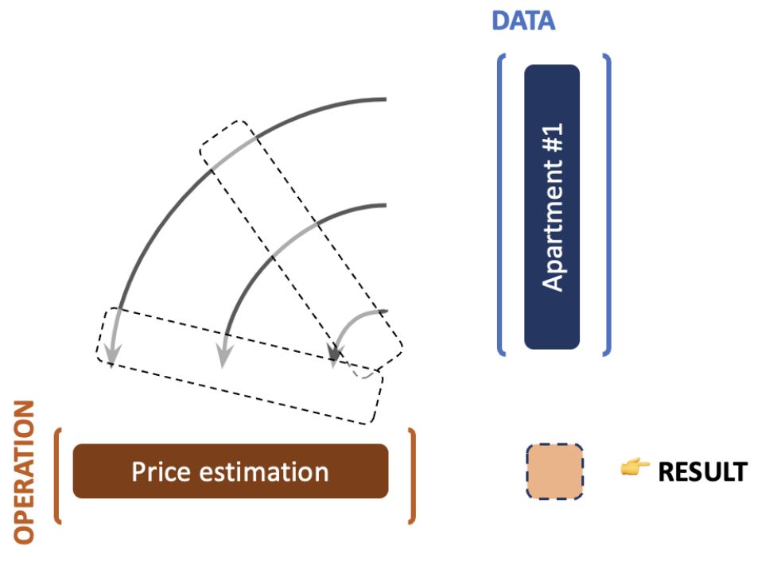

y

=

a

1

x

1

+

a

2

x

2

+

.

.

.

+

a

n

x

n

=

a

⋅

x

⎧

⎪

⎪

⎪

⎨

⎪

⎪

⎪

⎩

y

1

=

a

1

x

1

,

1

+

a

2

x

1

,

2

+

.

.

.

+

a

n

x

1

,

n

y

2

=

a

1

x

2

,

1

+

a

2

x

2

,

2

+

.

.

.

+

a

n

x

2

,

n

.

.

.

.

.

.

y

m

=

a

1

x

m

,

1

+

a

2

x

m

,

2

+

.

.

.

+

a

n

x

m

,

n

is equivalent to

y

=

a

⋅

X

👉 Estimate the price of *many* apartments (

y

) 🔥🔥 Vector • Matrix 🔥🔥

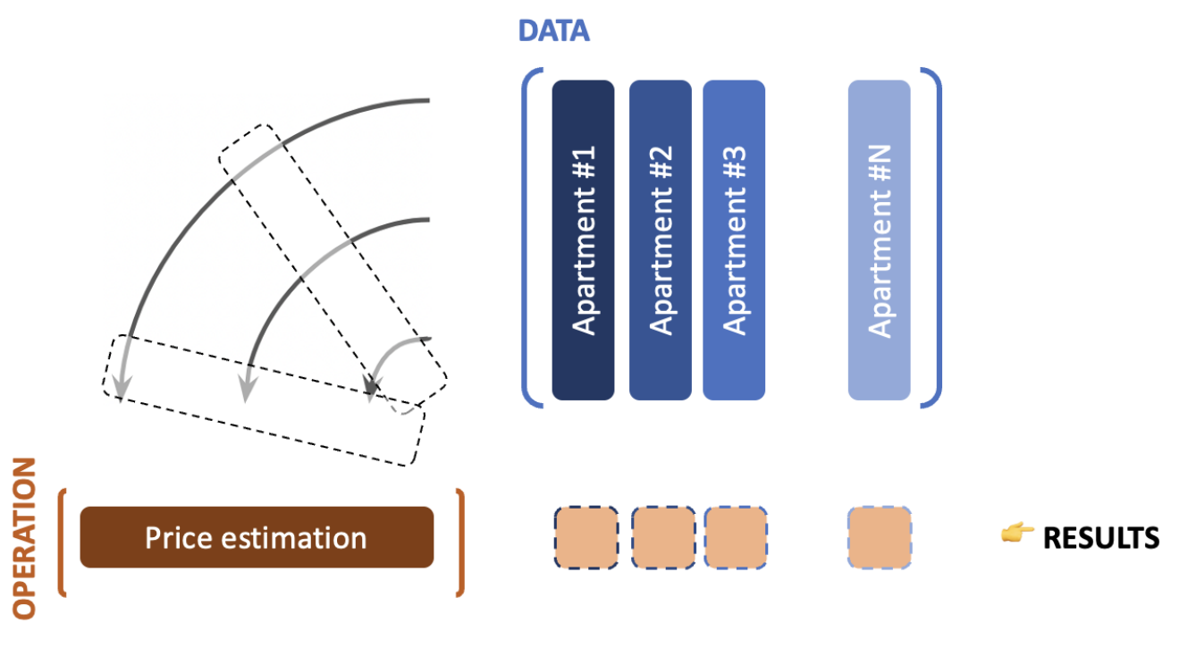

y

=

a

⋅

X

👉 Perform *many* operations on *many* apartments 🔥🔥🔥 Matrix • Matrix 🔥🔥🔥

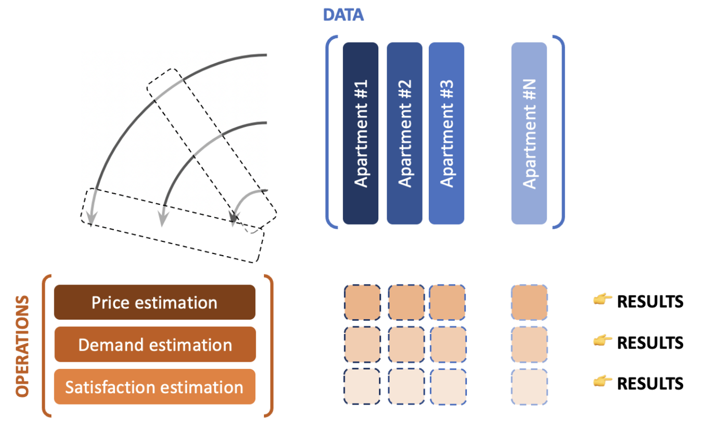

Y

=

A

⋅

X

One last thing:

#### **GPUs ❤️ matrix multiplication**

### **1.5.2) Solving a system of linear equations**

**Solving the father/daughter problem (again)**

{

1

⋅

x

1

+

(

−

1

)

⋅

x

2

=

22

1

⋅

x

1

+

(

−

2

)

⋅

x

2

=

10

⟺

A

⋅

x

=

b

... where:

A

=

[

1

−

1

1

−

2

]

,

x

=

[

x

1

x

2

]

and

b

=

[

22

10

]

👉 Multiply both sides of the equation with

A

−

1

on the left:

A

−

1

⋅

(

A

⋅

x

)

=

A

−

1

⋅

b

👉 Notice that:

A

−

1

⋅

(

A

⋅

x

)

=

(

A

−

1

⋅

A

)

⋅

x

=

I

2

⋅

x

=

x

👉 finally:

x

=

A

−

1

⋅

b

📝 With NumPy:

A = np.array([[1, -1], [1, -2]])

b = np.array([[22], [10]])

np.linalg.inv(A) @ b

array([[34.],

[12.]])

### **How did Numpy compute**

### A

### −

### 1

### **?**

We can use the [**Gaussian elimination**](https://en.wikipedia.org/wiki/Gaussian_elimination#Finding_the_inverse_of_a_matrix) algorithm which has a

O

(

n

3

)

**complexity**.

This complexity can still be [improved](https://en.wikipedia.org/wiki/Computational_complexity_of_mathematical_operations#Matrix_algebra) but we won't reach a complexity that is better than

O

(

n

2.3

)

😱

### **Computational complexity - "Big O" 🤔**

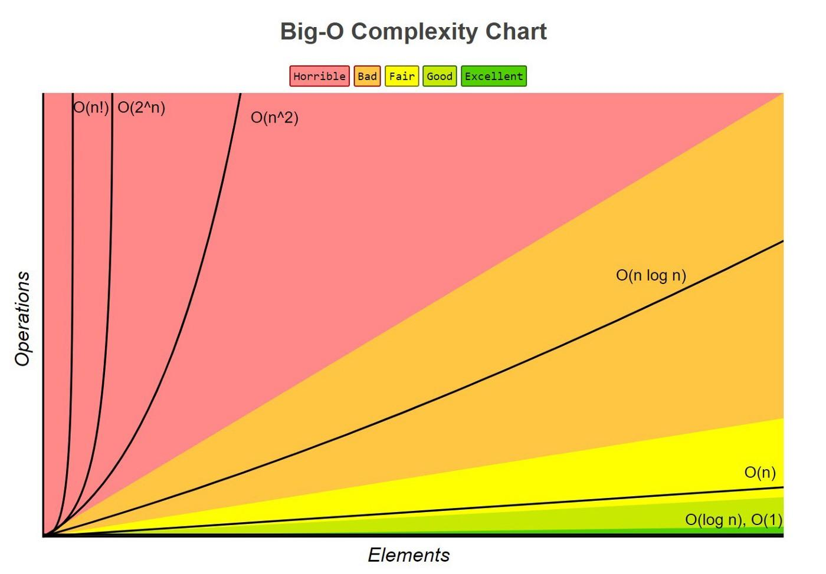

* O
* (
* 1
* )
* - get first element of a list
* O
* (
* l
* o
* g
* (
* n
* )
* )
* - find position of given element in a sorted list (divide & conquer)
* O
* (
* n
* )
* - print each elements of a list (simple loop)
* O
* (
* n
* l
* o
* g
* (
* n
* )
* )
* - sort a list
* O
* (
* n
* 2
* )
* - nested for loop
* O
* (
* 2
* n
* )
* - password cracking (brute force) or recursive functions

📚 [Towards Data Science - understanding time complexity](https://medium.com/towards-data-science/understanding-time-complexity-with-python-examples-2bda6e8158a7)

👉 [Recent research from DeepMind](https://www.deepmind.com/blog/discovering-novel-algorithms-with-alphatensor)



### **1.5.3) Change of basis and Projection**



[Linear transformations and matrices](https://www.youtube.com/watch?v=kYB8IZa5AuE&list=PLZHQObOWTQDPD3MizzM2xVFitgF8hE_ab&index=3) by 3blue1brown 🥰

Matrix Multiplication can represent a [Change of Basis](https://en.wikipedia.org/wiki/Change_of_basis) or a [Projection](https://en.wikipedia.org/wiki/Projection_%28linear_algebra%29).

i

becomes

[

a

c

b

d

]

⋅

[

1

0

]

=

[

a

b

]

while

j

becomes

[

a

c

b

d

]

⋅

[

0

1

]

=

[

c

d

]

💡 See PCA in the Unsupervised Learning Lecture (Week 5)

# **2) Calculus**

We will use:

* **derivatives** and **partial derivatives** in optimization problems
* **integrals** for probability distribution

## **2.1) Derivatives**

🤔 When

x

changes, how does

f

(

x

)

changes? This information is provided by

f

′

the [derivative](https://en.wikipedia.org/wiki/Derivative) of

f

👉 Let

f

:

R

→

R

a function

f

′

(

a

)

=

d

f

d

x

(

a

)

=

lim

h

→

0

f

(

a

+

h

)

−

f

(

a

)

h

💡 The derivative at one point is the local **slope** of the curve



## **2.2) Partial derivatives**

🤔 When

x

and

y

change, how does

g

(

x

,

y

)

changes? In that case we split the problem!

Let

g

:

R

2

→

R

a continuous bivariate function. The [partial derivatives](https://en.wikipedia.org/wiki/Partial_derivative) of

g

are:

∂

g

∂

x

(

x

A

,

y

A

)

=

lim

h

→

0

g

(

x

A

+

h

,

y

A

)

−

g

(

x

A

,

y

A

)

h

and

∂

g

∂

y

(

x

A

,

y

A

)

=

lim

h

→

0

g

(

x

A

,

y

A

+

h

)

−

g

(

x

A

,

y

A

)

h

👉 the partial derivatives at one point are the **slopes** (or rates of change) with respect to the "

x

" direction and to the "

y

" direction

**import** **plotly.graph_objects** **as** **go**

fun = **lambda** x, y: x**2 - y**2

x, y = np.meshgrid(np.linspace(-1, 1, 100), np.linspace(-1, 1, 100))

z = fun(x, y)

fig = go.Figure(go.Surface(x=x, y=y, z=z)); fig.show()